COMPUTER WORKSHOP – Charlie Church Mouse - Ruth

Charlie Church Mouse Early Elementary – Story of Ruth

Have program preloaded, if possible, so you can skip the beginning opening.

Select Ruth, after picking Difficulty Level – only words will be more difficult, not maze.
So none-readers should pick EASY. If they run the mouse over the words, it will say them out loud so they can listen for what words rhyme.

Field Games: keeping things fair!
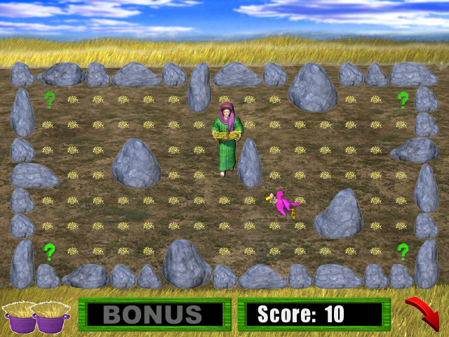
There are 3 fields and a bonus field, then 3 more fields & another bonus field, then lastly 3 more fields & a last bonus field. For a total of 12 fields. If you number the children at each computer and have the list below posted somewhere for all to see or better yet taped across the top of their monitors so everyone gets a fair share of games.)

- If 2 children – (#1, #2, #1, #1 // #2, #1, #2, #2 // #1, #2, #1, #2) - everyone will get 6 turns.
- If 3 children at a computer – everyone gets 4 turns (#1, #2, #3, #1 // #2, #3, #1, #2 // #3, #1, #2, #3)
- If 4 children at a computer – everyone gets 3 turns, (#1, #2, #3, #4 // #2, #3, #4, #1 // #3, #4, #1, #2)

- Opening story– meet Ruth & Noami –there back in Bethlehem and have nothing to eat.
Would there have been a tractor in Ruth’s time? NO
– clear first field – watch out for birds they will take your basket
– clear second field – watch out for 2 birds
– clear third filed – watch out for 2 birds + a gopher (watch out as you don’t know where the gopher will pop up and he will take your basket!)
– Bonus Round – move fast to collect as many as you can.

- Boaz meets Ruth and instructs his workers to give Ruth more grain and water.
What does Boaz arrive in the field on? Driving a horse wagon.
Watch for Boaz driving his wagon across the top of the screen. He’ll drop a bundle of grain or a jug of water. If you get to it before it disappears Ruth runs FAST for a minute!
– clear first field - 1 bird – clear second field - 2 birds
– clear third filed - 2 birds + gopher – Bonus Round – move fast to collect the most.

- Ruth tells Noami about Boaz’s kindness.
– clear first field - 1 bird – clear second field - 2 birds
– clear third filed - 2 birds + gopher – Bonus Round – move fast to collect the most.

- Ruth and Boaz get married and have a baby named Obed, who is the great, great, great grandfather of King David. Charlie Church Mouse talks about Ruth being faithful to God by helping Naomi and asks kids how they can be faithful to God? (Discuss ways to be faithful)

